**Low price but tasty**

1. Egg cake

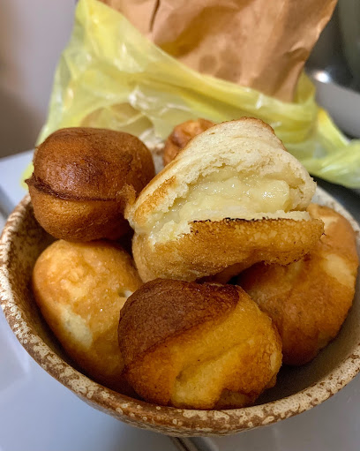

Name: 公館雞蛋糕 (It’s a stand with no shop name)

Location: <https://goo.gl/maps/es6GNJ7feHVtMGST6>

Yu-Pei’s info: It’s traditional Taiwanese snack. It tastes like harder soufflé(? There are three flavor original(without filling), cream and red bean. The seller can’t hear so you need to order by pointing what you want on the menu.

1. Martabak

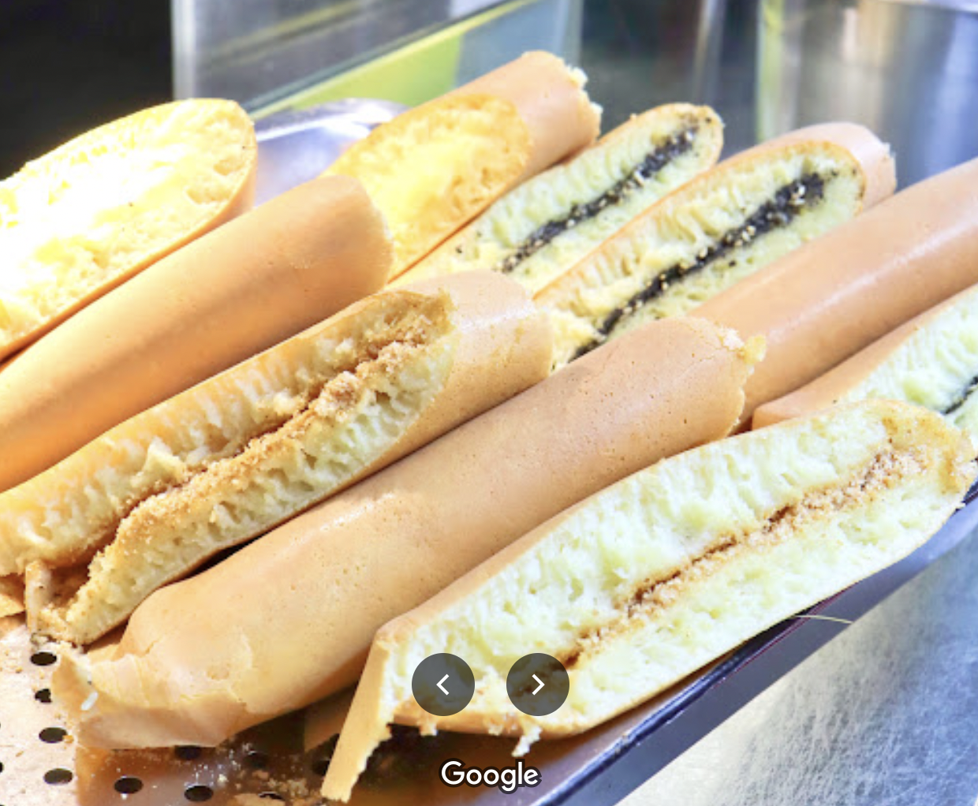

Name: 回味麵煎餅 (It’s a stand)

Location: <https://goo.gl/maps/HJUJSLVVA4cRSQRr9>

Yu-Pei’s info: It’s traditional Taiwanese snack. It tastes like pancake. There are different flavors for you to choose!

1. Wheel pie

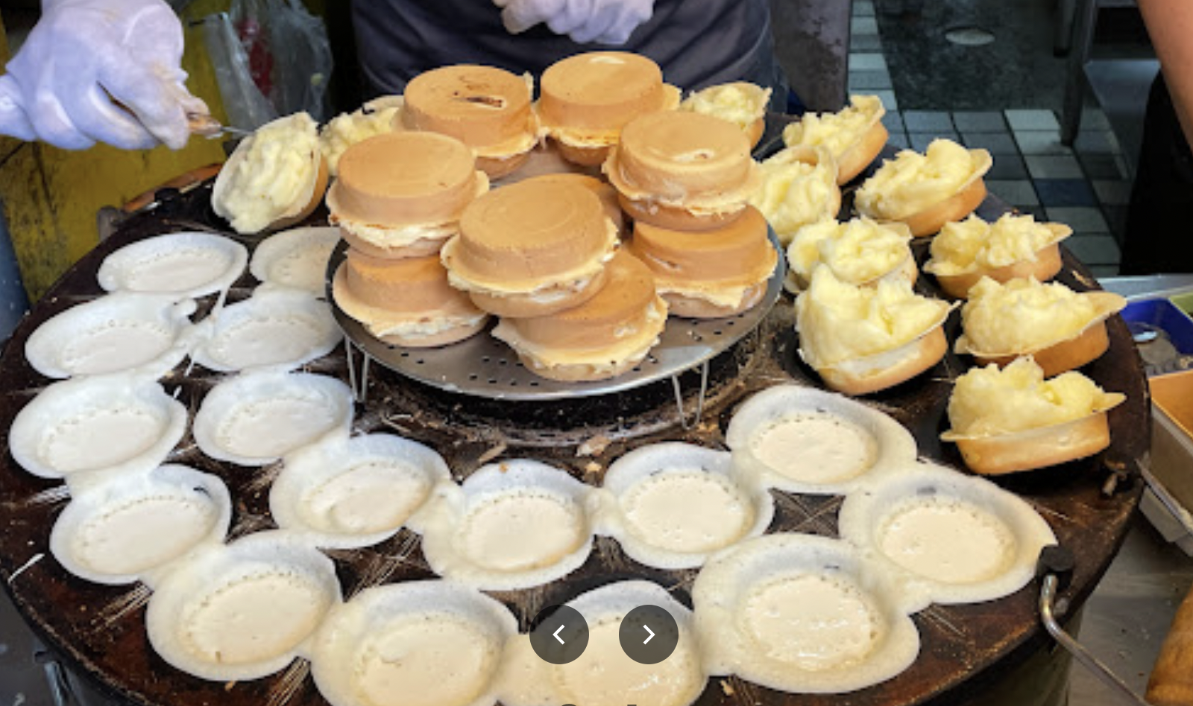

Name: 晴光紅豆餅

Location: <https://goo.gl/maps/zxiT7NWif6qYJbba7>

Yu-Pei’s info: It’s traditional Taiwanese snack. The crust is made of flour, eggs and sugar. The filling can be red beans or cream.

1. Brownie

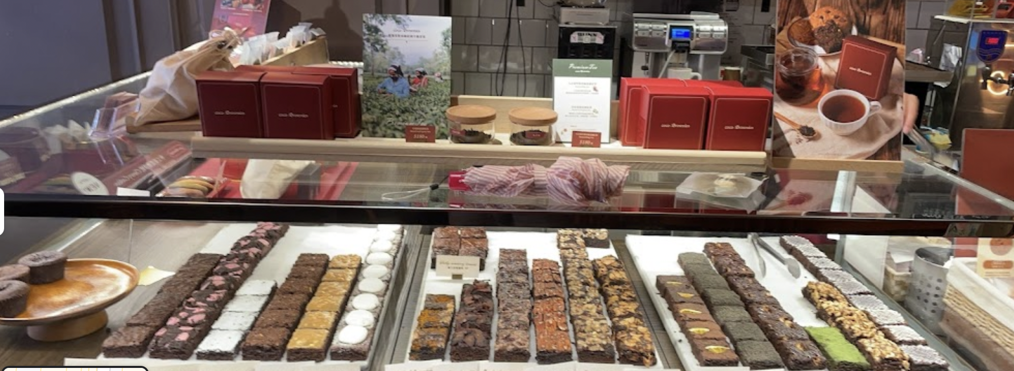

Name: coco Brownies

Location: <https://g.page/cocoBrownies?share>

Yu-Pei’s info: Five star!!!!!! High cp value!!!

1. Douhua

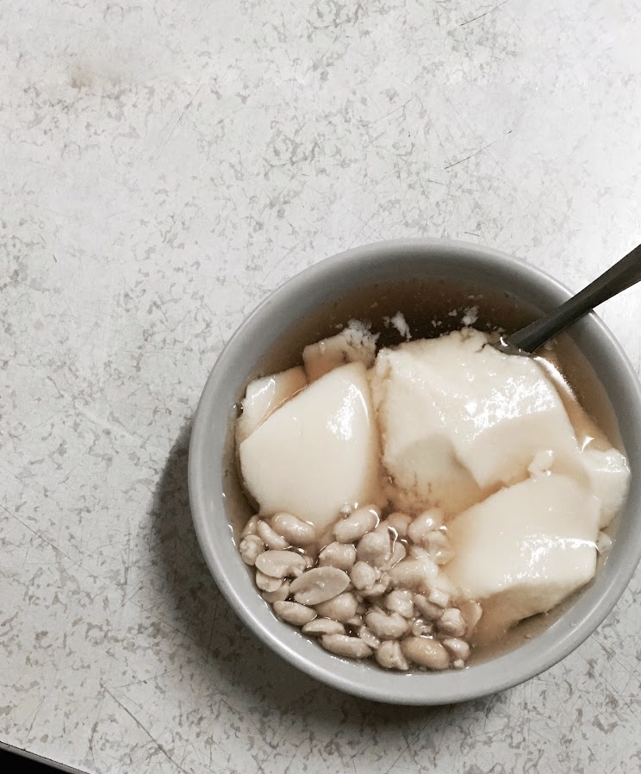

Name: 龍潭豆花

Location: <https://goo.gl/maps/jLFPpexitMAfk5wp8>

Yu-Pei’s info: It’s traditional Taiwanese snack. It’s kinda soybean pudding. This shop is the most famous douhua shop near NTU. Andy is the master of Douhua. He has tasted over 100 douhua shop around Taiwan and he can tell you many tasty douhua shop.

1. Shaved ice, sweet soup and tanyuan (sweet dumpling)

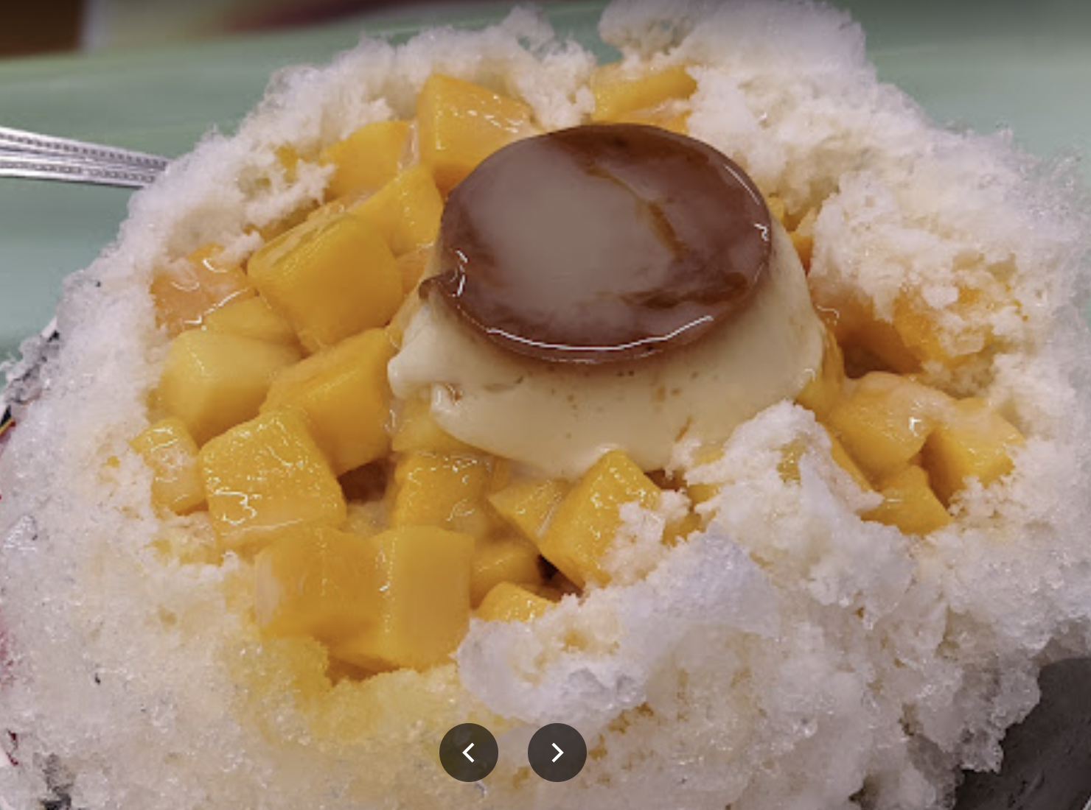 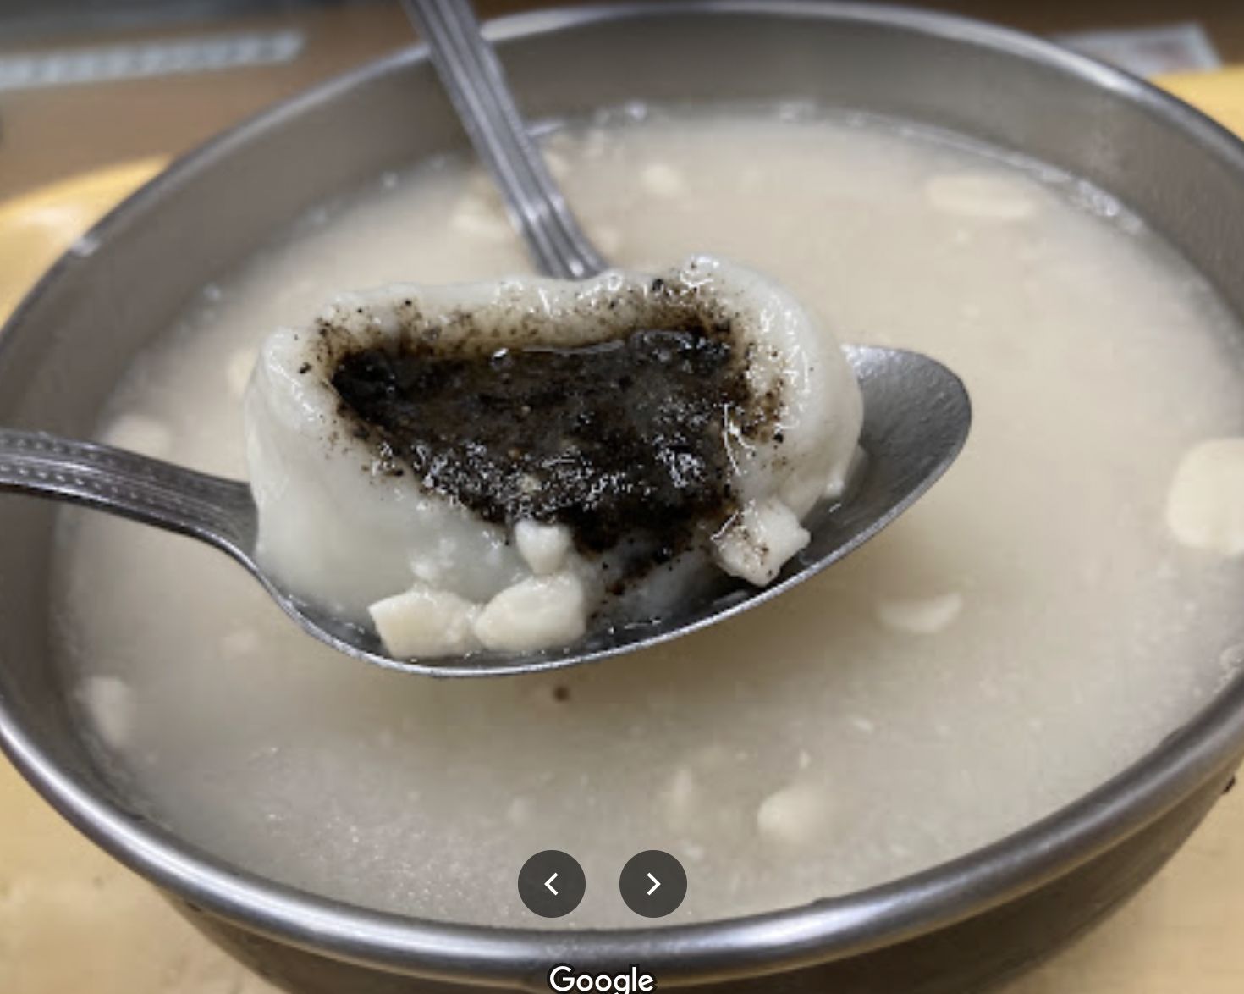

Name: Taiyi Milk King

Location: <https://goo.gl/maps/yS6tYn21QA7ctJFc6>

Yu-Pei’s info: It’s traditional Taiwanese snack. Also this is David’s favorite shop for tanyuan. We often eat shaved ice in summer and sweet soup in winter. There are several kinds of flavor!

1. Puff

Name: 人性甜點

Location: <https://g.page/humanity__sweets?share>

1. Crème Brulee

Name: 索菲烤布蕾公館店

Location: <https://goo.gl/maps/rkdBUACoNqTyBcqr6>

Yu-Pei’s info: It’s in the Shuiyuan Market (水源市場) building. It locates on the second floor.

1. Black rice with taro cake

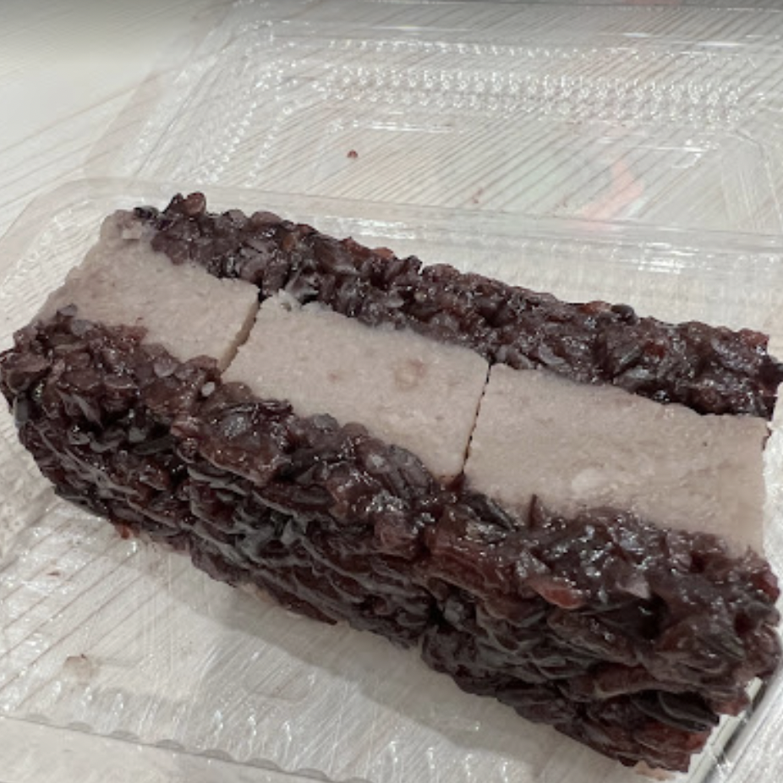

Name: 賢夫美食

Location: <https://g.page/XinFuDeliciousFood?share>

Yu-Pei’s info: It’s Hongkongers dessert. It’s in the Shuiyuan Market (水源市場) building. It locates on the first floor. You need to go buy earlier since it is so popular that it’s often sold out if you are late ;)

1. Waffle

Name: 小木屋鬆餅

Location: <https://goo.gl/maps/L9cPsZobuxCnrEbz8>

Yu-Pei’s info: Just in front of life science building!

**High price but tasty**

1. Name: Mania買你

Location: <https://goo.gl/maps/E7P9trzGE7ghtQEm8>

Yu-Pei’s info: Lemon tart is the most special dessert in this shop since the lemon tart it sell is sour flavor. If you don’t like sour dessert you can choose other flavor there are also tasty!

1. Name: Pica Pica Café

Location: <https://goo.gl/maps/AQNWjKP1m4r3cu6L6>

Yu-Pei’s info: Cinnamon roll is the most famous dessert in this shop.

1. Name: Flügel studio

Location: <https://g.page/fluegelstudio?share>

Yu-Pei’s info: pâtissier

**Low price but not so tasty**

1. Name: Tiramisu

Location: <https://goo.gl/maps/Hy7nLbBWW1urjbjS8>

Yu-Pei’s info: Freeze their Tiramisu. It’ll taste better XD (better than put it in cold storage)